1. Write a program to place Name, Age and mobile number linearly (Vertical) on the display screen using Linear layout

activity_main.xml

<?xml version="1.0" encoding="utf-8"?>  
<LinearLayout  
 xmlns:android="http://schemas.android.com/apk/res/android"  
 android:layout_width="match_parent"  
 android:layout_height="match_parent"  
 android:orientation="vertical"  
 android:padding="16dp"  
 android:gravity="center">  
  
 <TextView  
 android:id="@+id/textViewName"  
 android:layout_width="match_parent"  
 android:layout_height="wrap_content"  
 android:background="#03A9F4"  
 android:text="Name: Meet"  
 android:textColor="#000000"  
 android:textSize="24sp"  
 android:textStyle="bold"  
 android:padding="8dp" />  
  
 <TextView  
 android:id="@+id/textViewAge"  
 android:layout_width="match_parent"  
 android:layout_height="wrap_content"  
 android:background="#FFC107"  
 android:text="Age: 18"  
 android:textColor="#000000"  
 android:textSize="24sp"  
 android:textStyle="bold"  
 android:padding="8dp" />  
  
 <TextView  
 android:id="@+id/textViewMobile"  
 android:layout_width="match_parent"  
 android:layout_height="wrap_content"  
 android:background="#03A9F4"  
 android:text="Mobile No: 123456789"  
 android:textColor="#000000"  
 android:textSize="24sp"  
 android:textStyle="bold"  
 android:padding="8dp" />  
  
</LinearLayout>

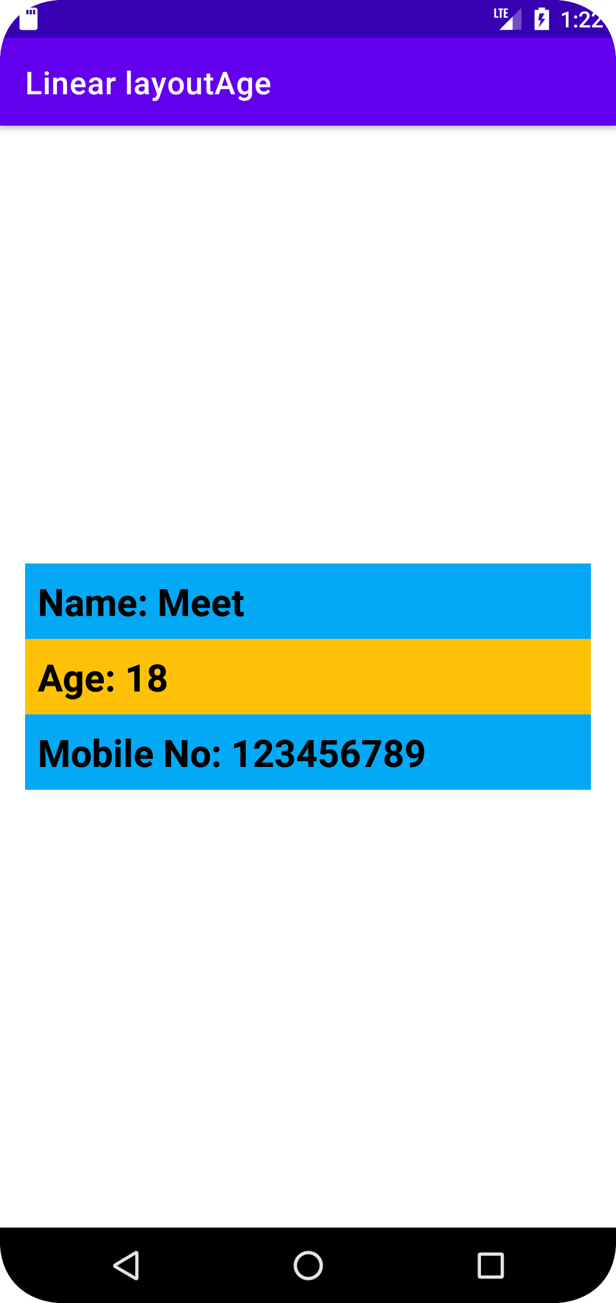

1. Write a program to place Name, Age and mobile number centrally on the display screen using Absolute layout.  
     
   activity_main.xml

<?xml version="1.0" encoding="utf-8"?>

<AbsoluteLayout

xmlns:android="http://schemas.android.com/apk/res/android"

android:layout_width="match_parent"

android:layout_height="match_parent"

android:background="#c7ffd8"

>

<TextView

android:id="@+id/textView"

android:layout_width="wrap_content"

android:layout_height="wrap_content"

android:layout_x="100dp"

android:layout_y="250dp"

android:text="Name: Meet"

android:textColor="#161d6f"

android:textSize="22sp"

android:textStyle="bold" />

<TextView

android:id="@+id/textView2"

android:layout_width="wrap_content"

android:layout_height="wrap_content"

android:layout_x="100dp"

android:layout_y="300dp"

android:text="Age: 18"

android:textColor="#161d6f"

android:textSize="22sp"

android:textStyle="bold" />

<TextView

android:id="@+id/textView3"

android:layout_width="wrap_content"

android:layout_height="wrap_content"

android:layout_x="100dp"

android:layout_y="350dp"

android:text="Phone No: 123456789"

android:textColor="#161d6f"

android:textSize="22sp"

android:textStyle="bold" />

</AbsoluteLayout>

